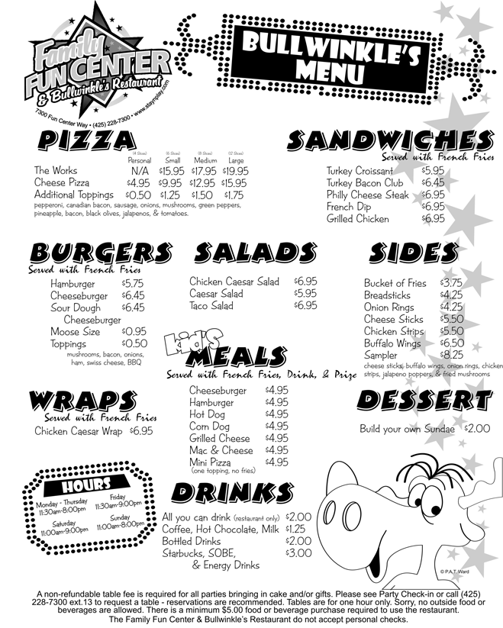
Bullwinkle’s Restaurant
1) How much is a large “Cheese Pizza” with extra onions and bacon?
_____________________________________________________________________
2) If I order a burger, do I automatically get french fries too?
_____________________________________________________________________
3) What do the Americans call fried chicken wings/legs?
_____________________________________________________________________
4) If I order a children’s meal, what will come together with it?
_____________________________________________________________________
5) Does the restaurant serve ice-cream?
_____________________________________________________________________
6) Does the restaurant open on Sundays for lunch?
_____________________________________________________________________
7) Does the restaurant let me take a birthday cake to my table?
_____________________________________________________________________
8) How much time can I stay in the restaurant?
_____________________________________________________________________
9) Does the restaurant accept checks as payment?
_____________________________________________________________________
10) If you spend $78 on your meal, how much tip would you give to your waiter/waitress?
_____________________________________________________________________

